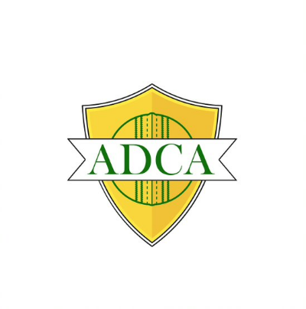
ADCA Indoor Cricket Winter 2026 Competition

Game Duration & Start Times
Game duration is 50min for 6 a side match.
Games start at 5:50pm continuing at the relevant time intervals, all players should be at the centre no later than 5 minutes prior to the scheduled game time.

Divisions: Social: Wednesday & Thursday nights (6 a side)

Basic Rules
Each pair bats for 4 overs and each player bowls for 2 overs. Bowling overs can be in any order; however one player cannot bowl two overs in a row.
Bonus runs can be scored by hitting the side and back nets. A full explanation of bonus runs can be obtained from the umpire.
Your team can never go all out, a wicket results in a loss of 5 runs to the team

Ladders & Points System
Win / Forfeit Win – 4 Points
Draw – 2 Points
Loss / Forfeit Loss – 0 Points
Uniform
All players in a team must compete in the same coloured shirts. Shirts may be of any colour or style, provided ALL team mates wear the exact same colour. All teams must adhere to this by Round 3 of the regular competition.
Game Fees
Each team has a registration fee of $120 paid prior to the season commencing, weekly team fees are $60 (6 aside) which must be paid to umpires in cash prior to the start of each match.
Team Registration
https://www.cognitoforms.com/AlbanyDistCA/ADCAIndoorCricketCompetitionTeamRegistration
Player Registrations:
Players must be registered to the Albany & District Cricket Association prior to participation (registration is FREE) https://www.playhq.com/cricket-australia/register/796ebb

ADCA Indoor Cricket Proudly Sponsored by


